1. SWITCH

**import** java.util.Scanner;

**public** **class** Test {

**public** **static** **void** main(String[] args) {

System.***out***.println("请输入月份：");

Scanner sc = **new** Scanner (System.***in***);

**int** month = sc.nextInt();

**switch** (month) {

**case** 1:

**case** 2:

**case** 3:

System.***out***.println("第一季度");

**break**;

**case** 4:

**case** 5:

**case** 6:

System.***out***.println("第二季度");

**break**;

**case** 7:

**case** 8:

**case** 9:

System.***out***.println("第三季度");

**break**;

**case** 10:

**case** 11:

**case** 12:

System.***out***.println("第四季度");

**break**;

**default**:

System.***out***.println("输入错误");

**break**;

}

}

}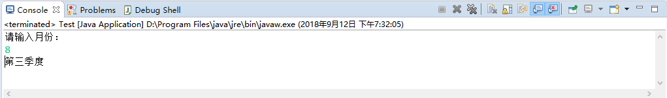

1. If循环

**import** java.util.Scanner;

**public** **class** month {

**public** **static** **void** main(String[] args) {

System.***out***.println("请输入月份：");

Scanner sc = **new** Scanner(System.***in***);

**int** month = sc.nextInt();

**if**(month == 0) {

System.***out***.println("输入错误");

}**else** **if** (month < 4 ) {

System.***out***.println("第一季度");

}**else** **if** (month < 7) {

System.***out***.println("第二季度");

}**else** **if** (month < 9) {

System.***out***.println("第三季度");

}**else** **if** (month < 13) {

System.***out***.println("第四季度");

}**else** {

System.***out***.println("输入错误");

}

}

}